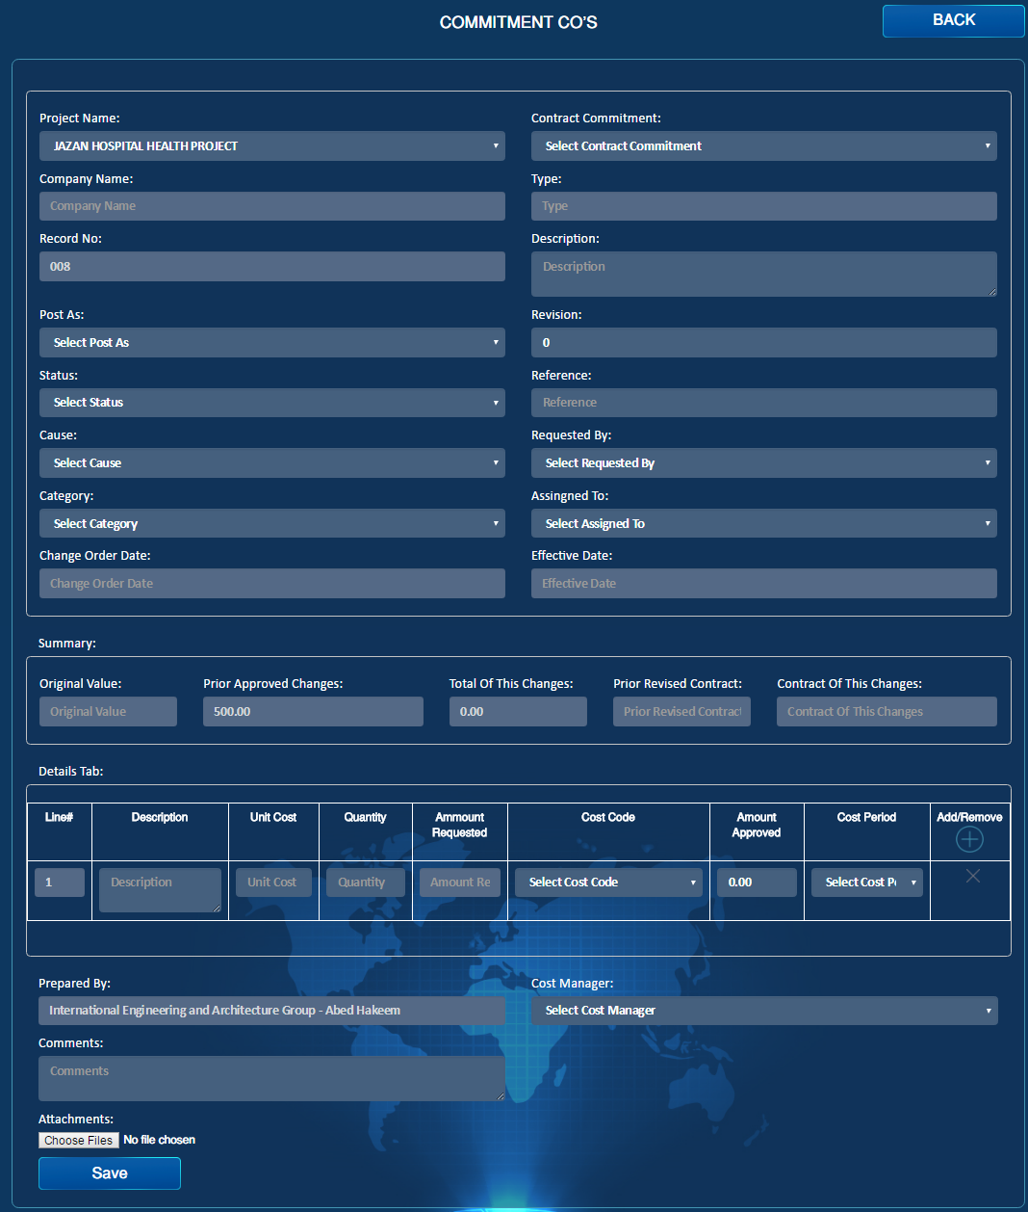

Show Links

Import

Import

Export

Import

Link to Change Request

Import

Add Items

Import

SWI #

Import

Re-name to “Change Order”

Contract

Transmittal Letter

Import

Email

Import

PDF

Import

Approve

Import

Submit

Import

Draft

Import

Reject

Import

1. Post As should include Original Scope or New scope
2. Cause should include: new scope, design changes
3. Category should include: Cost, Time and Cost & Time.
4. Remove Type field
5. SWI # should be a field in the change order form, it will be optional so if the change order is a result of SWI then SWI # can be filled - (It might be automatically generated from SWI form)
6. Create Items button should be optional from there you will get Pop – up to choose which report you want to add to (Engineering Log, Material Log, Procurement Log, Vendor Register), then you fill the form manually and the line item number will be starting with (CO/ ).
7. Link to option should be there to include (Engineering Log, Procurement Register, Material Log, Vendor Register, SWI) – it will be in add new or edit pages
8. Link to change request will show a pop-up then you choose the request, then the data in that request will be populated to this change order.
9. PDF & Email to be included

Re-name to “Change Order”

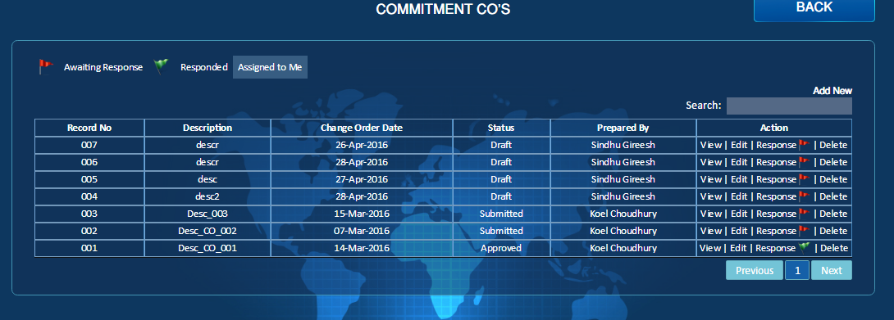

Category

Import

No Action Required

Import

Action Require

Import

Draft

Import